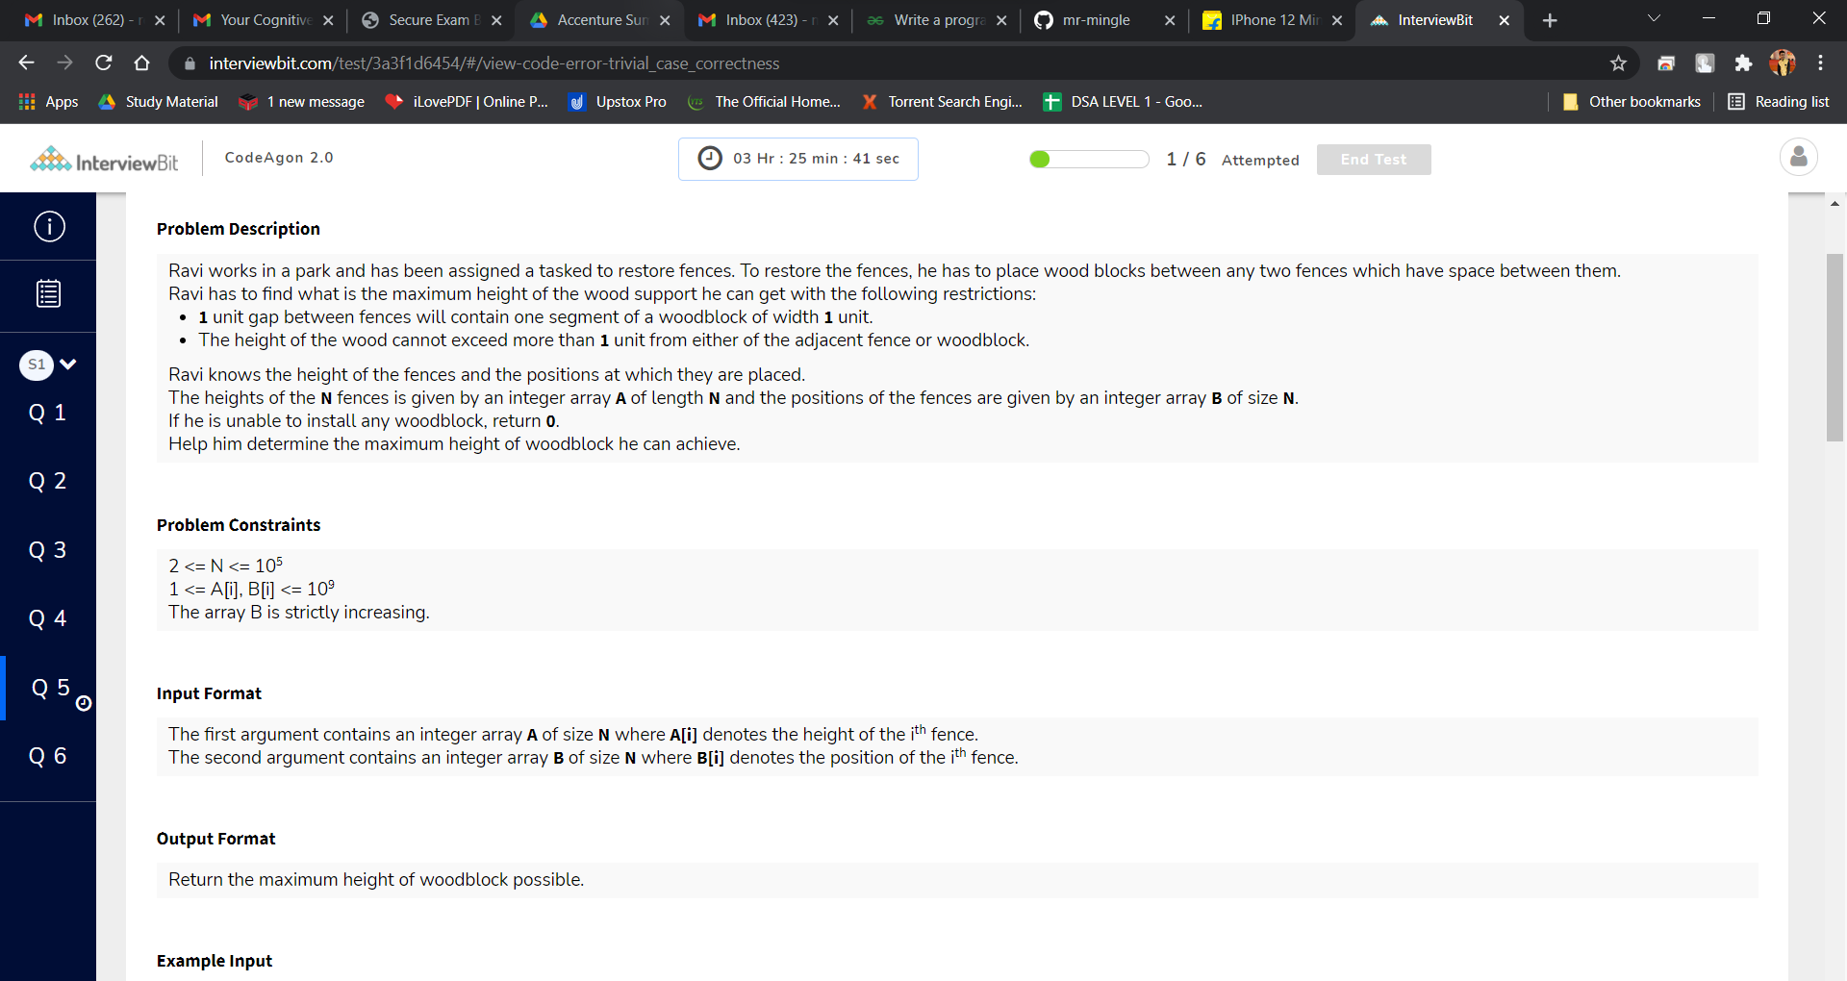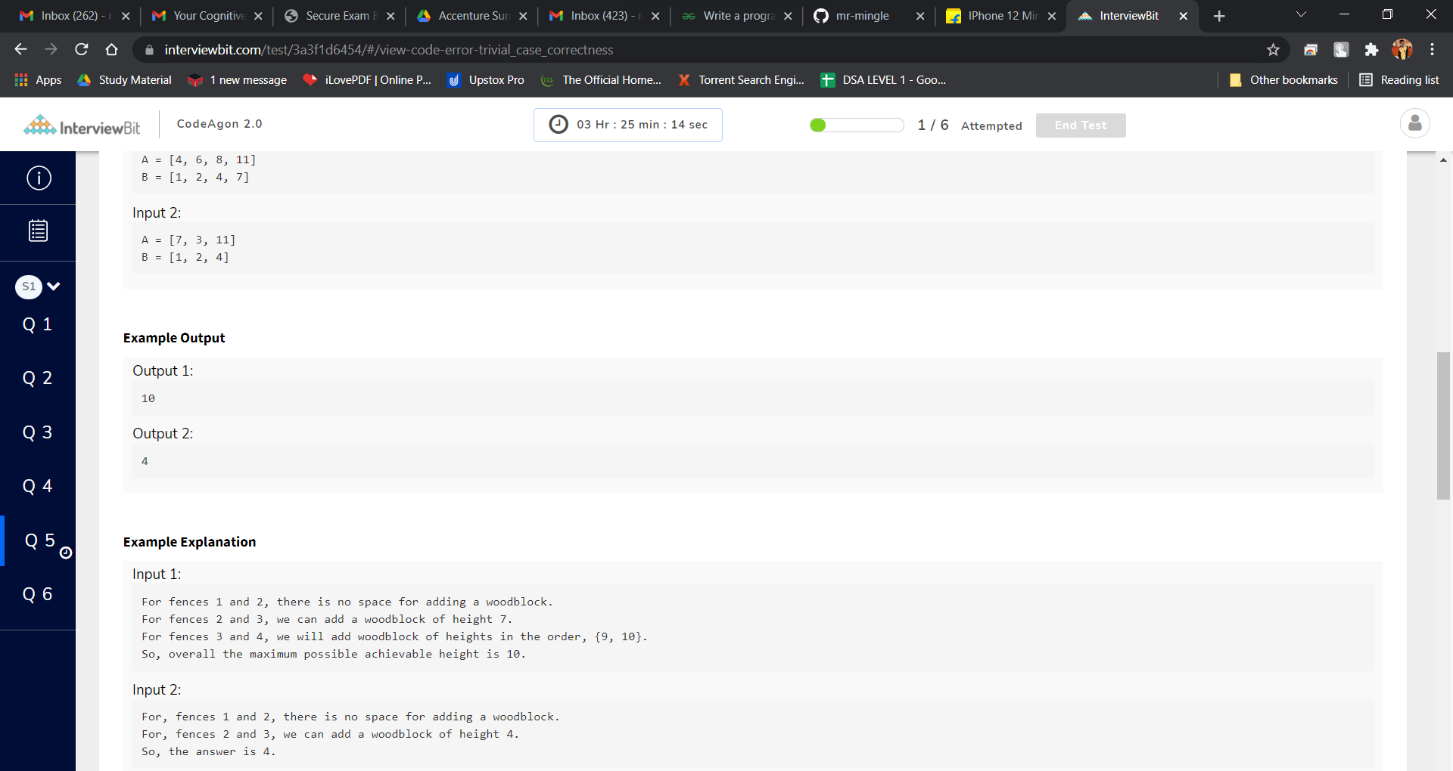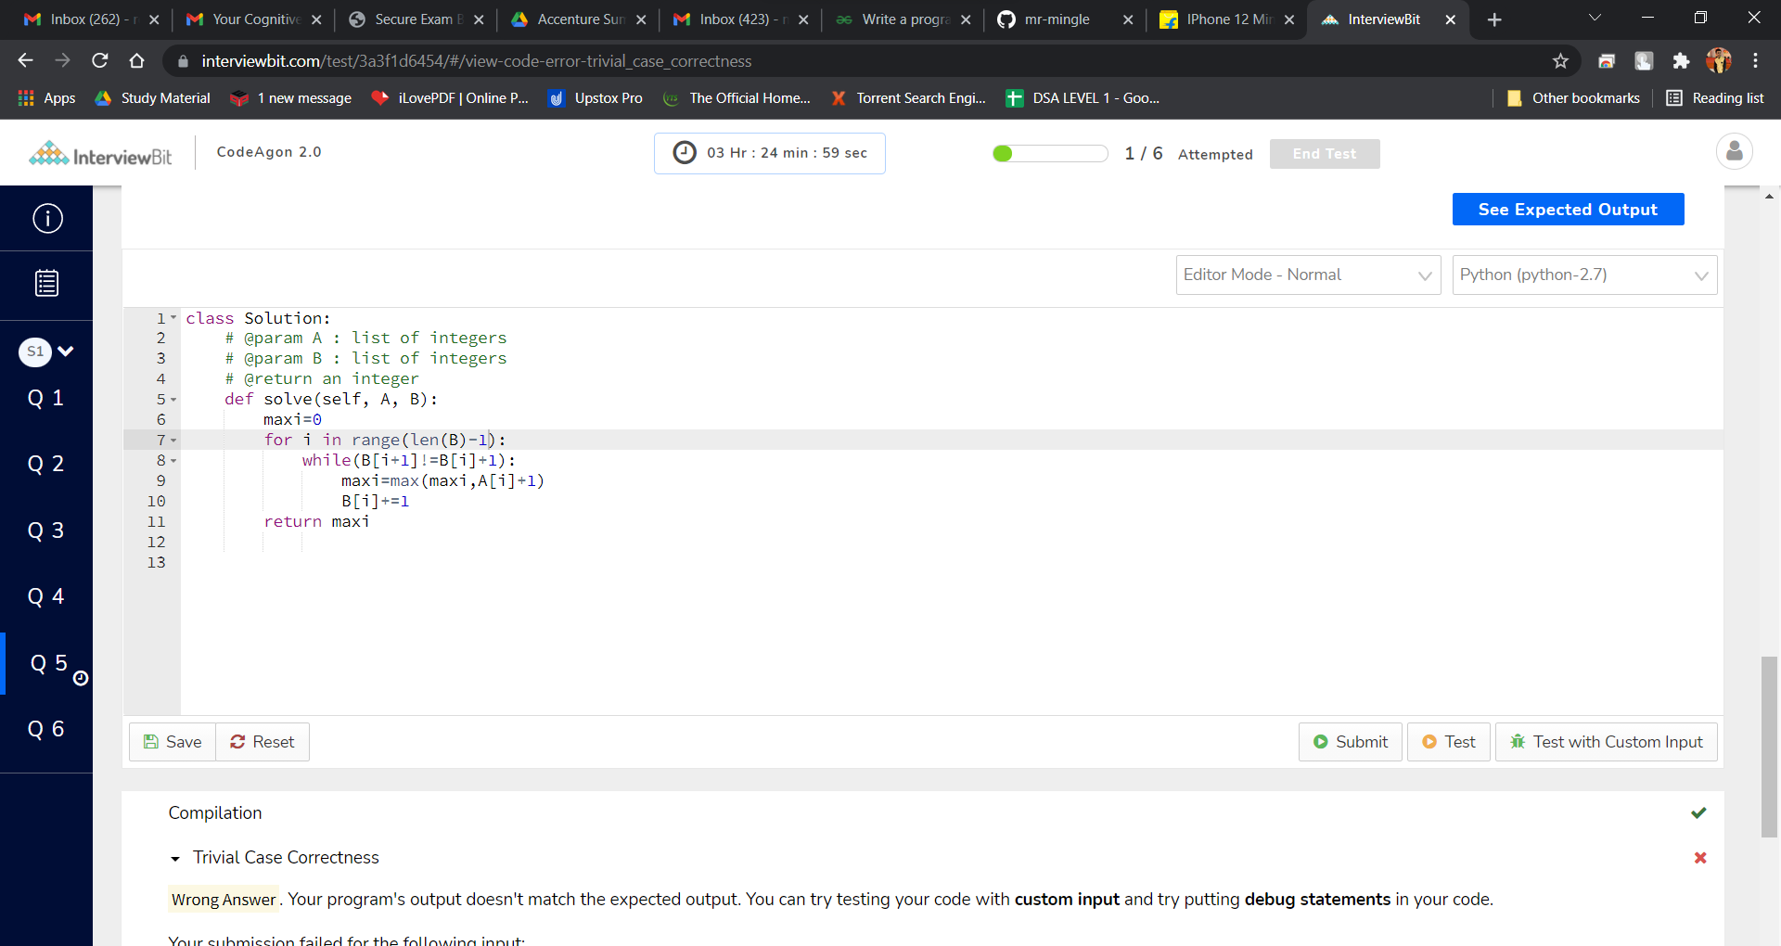class Solution:

# @param A : list of integers

# @param B : list of integers

# @return an integer

def solve(self, A, B):

maxi=0

for i in range(len(B)-1):

while(B[i+1]!=B[i]+1):

maxi=max(maxi,A[i]+1)

B[i]+=1

return maxi

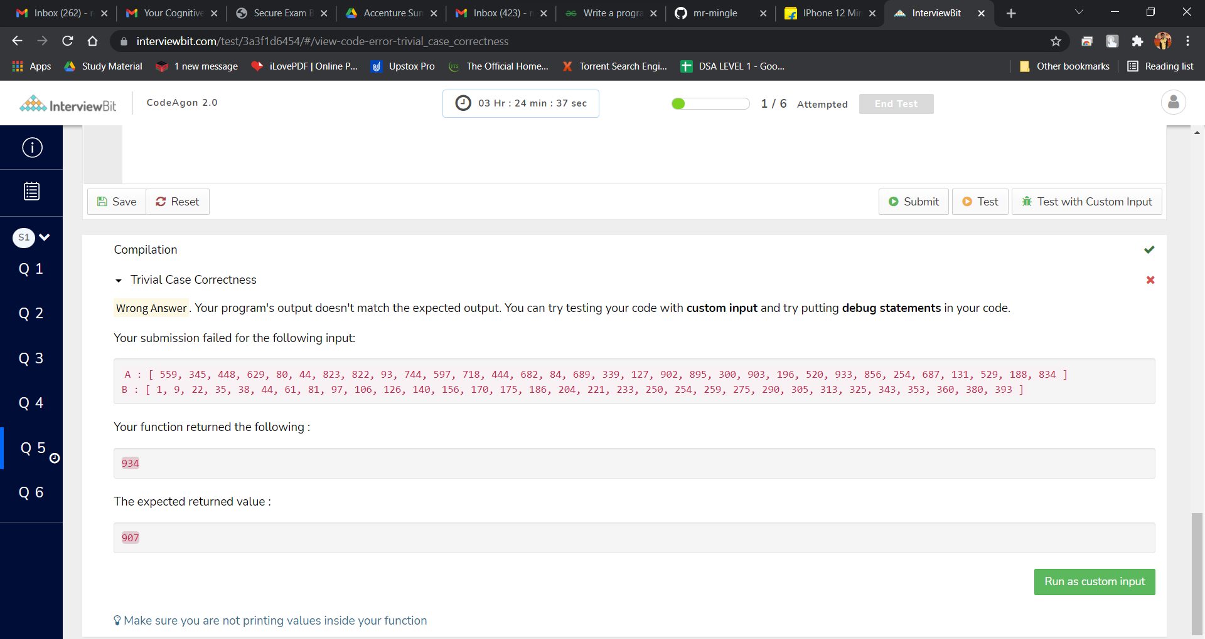SS